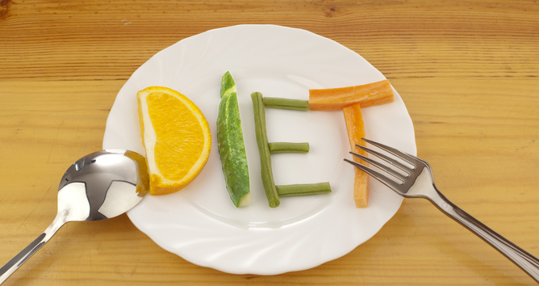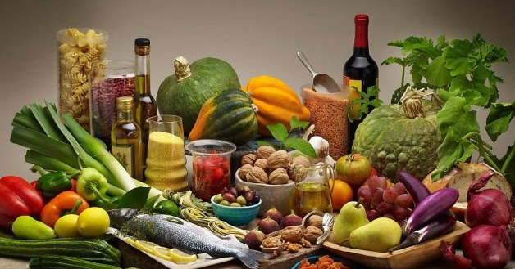
Unit 2 Food Extended (300 pts. Total .33 pts. each)
- Presentation skills practice – The student will stand at the Activboard and deliver some of the presentation skills necessary to pass the skills portion of the unit. They must set the pen, highlight two times, use emphasis, point to two items, and use the clicker to advance or the ppt. slide controls. The student will have this checked off by my interns or myself. (2) 20 pts.
- Solutions PowerPoint – The student will add 10 slides to the ppt. with the transition recap, the solutions, and the references. (3) 40 pts.
- Unique solutions list – In teams, students will compile list of ideas to solve their group problem. The list of 5 ideas need to be explained and URL given. These lists will be shared in a document so the whole class will receive. (2) 20 pts.
- Solutions research and unique idea – Students will research real life examples to solve their individual problems. They must be outside of the US. (2) 20 pts.
- Scaffolding on causes and solutions – The student will combine the unit 3 causes with the unit 3 solutions to create the backbone of the presentation. (2) 40 pts.
- Note Cards – The full presentation will be placed on notecards. Paper will not be accepted. I will loan notecards to anyone who needs them. (1) 20 pts.
- Create a 4 minute video and record using the Activboard – The student will record the first half of the presentation on the Activboard and tape with their camera phone. It will be timed and assisted by their team member. (4) 50 pts.
- Reflective essay –The student will write an 800- word reflective essay on the experience. (3) 40 pts.
- Create a 4 minute video on the solutions with closing. It will be done at the Activboard and assisted by a team member. (4) 50 pts.

